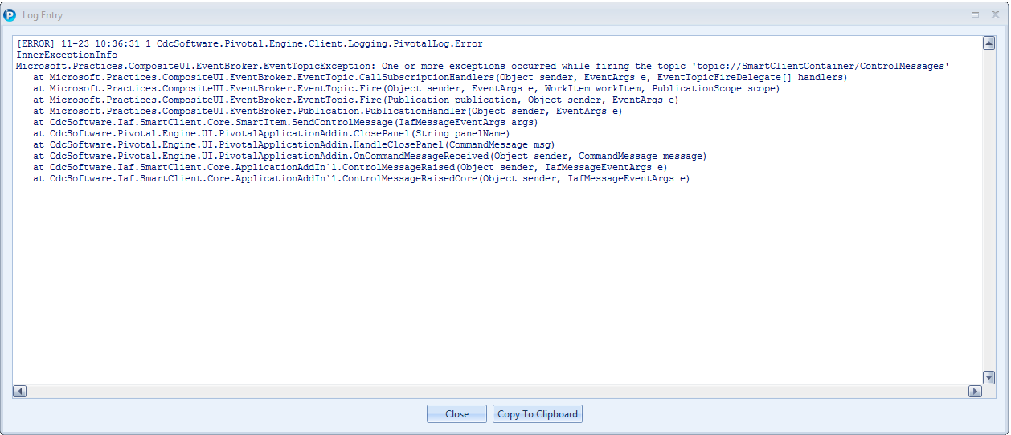

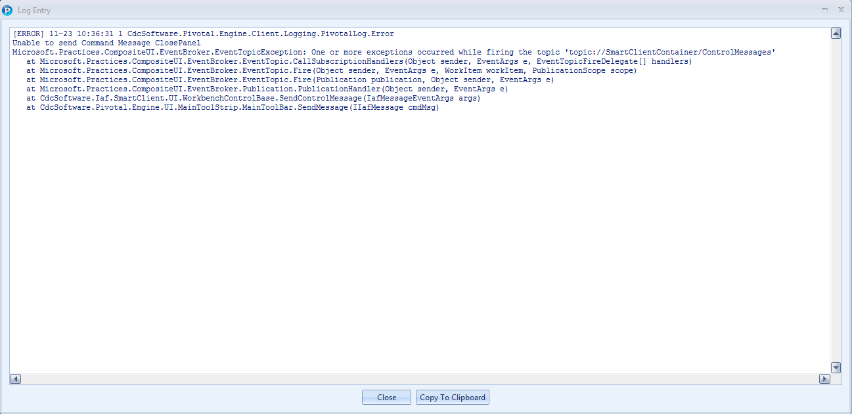

One or more exceptions occurred while firing the topic 'topic://SmartClientContainer/ControlMessages'

Microsoft.Practices.CompositeUI.EventBroker.EventTopicException: One or more exceptions occurred while firing the topic 'topic://SmartClientContainer/ControlMessages'

   at Microsoft.Practices.CompositeUI.EventBroker.EventTopic.CallSubscriptionHandlers(Object sender, EventArgs e, EventTopicFireDelegate[] handlers)

   at Microsoft.Practices.CompositeUI.EventBroker.EventTopic.Fire(Object sender, EventArgs e, WorkItem workItem, PublicationScope scope)

   at Microsoft.Practices.CompositeUI.EventBroker.EventTopic.Fire(Publication publication, Object sender, EventArgs e)

   at Microsoft.Practices.CompositeUI.EventBroker.Publication.PublicationHandler(Object sender, EventArgs e)

   at CdcSoftware.Iaf.SmartClient.Core.Workbench`2.SendControlEvent(IafMessageEventArgs e)

   at CdcSoftware.Iaf.SmartClient.Core.Workbench`2.RaisePanelClosed(ISccPanel panel)

   at CdcSoftware.Iaf.SmartClient.Core.Workbench`2.CloseInternal(TPanel panel)

   at CdcSoftware.Iaf.SmartClient.Core.Workbench`2.Close(ISccPanel panel)

   at CdcSoftware.Iaf.SmartClient.UI.WpfWorkbenchBase.Close(SccWpfPanel panel)

   at CdcSoftware.Iaf.SmartClient.UI.WpfWorkbenchBase.OnClosing(CancelEventArgs e)

   at System.Windows.Window.WmClose()

   at System.Windows.Window.WindowFilterMessage(IntPtr hwnd, Int32 msg, IntPtr wParam, IntPtr lParam, Boolean& handled)

   at System.Windows.Interop.HwndSource.PublicHooksFilterMessage(IntPtr hwnd, Int32 msg, IntPtr wParam, IntPtr lParam, Boolean& handled)

   at MS.Win32.HwndWrapper.WndProc(IntPtr hwnd, Int32 msg, IntPtr wParam, IntPtr lParam, Boolean& handled)

   at MS.Win32.HwndSubclass.DispatcherCallbackOperation(Object o)

   at System.Windows.Threading.ExceptionWrapper.InternalRealCall(Delegate callback, Object args, Int32 numArgs)

   at MS.Internal.Threading.ExceptionFilterHelper.TryCatchWhen(Object source, Delegate method, Object args, Int32 numArgs, Delegate catchHandler)

Exception data:

System.Object:

   at Microsoft.Practices.CompositeUI.EventBroker.EventTopic.CallSubscriptionHandlers(Object sender, EventArgs e, EventTopicFireDelegate[] handlers)

   at Microsoft.Practices.CompositeUI.EventBroker.EventTopic.Fire(Object sender, EventArgs e, WorkItem workItem, PublicationScope scope)

   at Microsoft.Practices.CompositeUI.EventBroker.EventTopic.Fire(Publication publication, Object sender, EventArgs e)

   at Microsoft.Practices.CompositeUI.EventBroker.Publication.PublicationHandler(Object sender, EventArgs e)

   at CdcSoftware.Iaf.SmartClient.Core.Workbench`2.SendControlEvent(IafMessageEventArgs e)

   at CdcSoftware.Iaf.SmartClient.Core.Workbench`2.RaisePanelClosed(ISccPanel panel)

   at CdcSoftware.Iaf.SmartClient.Core.Workbench`2.CloseInternal(TPanel panel)

   at CdcSoftware.Iaf.SmartClient.Core.Workbench`2.Close(ISccPanel panel)

   at CdcSoftware.Iaf.SmartClient.UI.WpfWorkbenchBase.Close(SccWpfPanel panel)

   at CdcSoftware.Iaf.SmartClient.UI.WpfWorkbenchBase.OnClosing(CancelEventArgs e)

   at System.Windows.Window.WmClose()

   at System.Windows.Window.WindowFilterMessage(IntPtr hwnd, Int32 msg, IntPtr wParam, IntPtr lParam, Boolean& handled)

   at System.Windows.Interop.HwndSource.PublicHooksFilterMessage(IntPtr hwnd, Int32 msg, IntPtr wParam, IntPtr lParam, Boolean& handled)

   at MS.Win32.HwndWrapper.WndProc(IntPtr hwnd, Int32 msg, IntPtr wParam, IntPtr lParam, Boolean& handled)

   at MS.Win32.HwndSubclass.DispatcherCallbackOperation(Object o)

   at System.Windows.Threading.ExceptionWrapper.InternalRealCall(Delegate callback, Object args, Int32 numArgs)

   at MS.Internal.Threading.ExceptionFilterHelper.TryCatchWhen(Object source, Delegate method, Object args, Int32 numArgs, Delegate catchHandler)